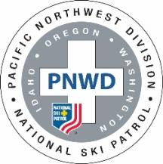 | PNWD ALL DISCIPLINE  INSTRUCTOR CONTINUING EDUCATION (ICE) CONFERENCE  June 4, 2022 Mt. Hood  Creekside Lodge (aka Clubhouse) at Collins Lake, Government Camp, OR  Registration Form  Must register by May 20, 2022 | 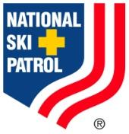

Please complete and send to:
Kathy Lee
6535 SE Jennings Ave
Milwaukie, OR 97267
leek232@gmail.com

Name: _______________________________________NSP #: _____________ Mentee ____ Y/N
Patrol Area: ________________________________________________________
Contact Phone Number: _________________ E-Mail: _______________________

Select Discipline (Only one):
Avalanche____ ID____ MTR____ Nordic/Backcountry_____ OEC____ OET____

Course Numbers
All must enroll in this course
NSP Instructor Skills Review for Continuing Education: P024220002

Then must enroll in one of the selected discipline courses below
Note: Avalanche, MTR and Nordic/Backcountry are holding a combined session which requires some pre-work prior to attending - contact Eric Geisler, ericsgeisler@yahoo.com, Matt Strauser, matt@bridgebuildersint.com

Avalanche Instructor CE: P059220004
ID ICE: P024220001
MTR ICE: P601220001
Nordic/Backcountry ICE: P022220018
OET ICE: P006220005
OEC ICE (Morning): P029220003 OEC-MSP Trainer Evaluator Clinic (Afternoon): P029220004

Lodging:
Collins Lake Resort Chalet and Grand Lodge rentals: 10% discount, ask for NSP2022 : 800-234-6288
https://www.collinslakeresort.com/
Best Western: www.bestwesternoregon.com/hotels/best-western-mt-hood-inn 503-272-3205 Note: Pets are not allowed
Vacasa: provides a listing of all types of lodging in Government Camp https://www.vacasa.com/
Have an RV? Mt Hood Village RV Park is 15 miles from the mountain www.rvonthego.com/oregon/mt-hood-village-rv-resort

Reimbursement: Mileage and lodging (1/2 of double occupancy) will be reimbursed up to $200/instructor if a reimbursement form is submitted, accompanied by all detailed receipts, after attendance at the conference.
For additional information, please contact
Kathy Lee, PNWD Asst. OEC Supervisor; leek232@gmail.com
Leisa Garrett, PNWD Asst. OEC Supervisor; leisag4@gmail.com
Kathy Alexander, PNWD Instructor Development Supervisor; katalexander911@mail.com

